The Department of History Invites you to a Talk by:

Professor Elizabeth Buettner
Professor of History
University of Amsterdam

‘Postcolonial Migration Meets European Integration:
Britain in Comparative Perspective’

How exceptional has Britain’s history of inward migration after 1945 been compared to that of other Western European countries? Like other former imperial powers, Britain became home to many peoples from its former colonies and Commonwealth, many of whom were not of European descent; moreover, like many of its continental neighbours Britain too attracted migrants from other European countries. How did common responses to newcomers from outside Europe resemble or differ from attitudes towards foreign Europeans, particularly those from within the European Economic Community/European Union? This paper will sketch out general issues and discuss changes over time, not least by comparing earlier decades to developments occurring after EU’s eastward enlargement since 2004 that have culminated in Brexit.

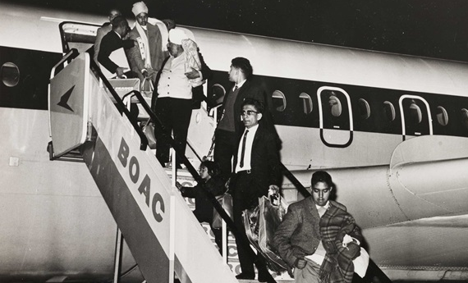

October 22, 2019
HSSB 4020
4:00-6:00

Thank you to our co-sponsors:
Departments of History; Global Studies; Political Science; Sociology; Migrations Initiative, Kapany Chair in Sikh Studies

Elizabeth Buettner is Professor of Modern History at the University of Amsterdam. Her publications encompass earlier work on Britain and late imperial India and memories of the ‘Raj’ in postcolonial Britain, particularly Empire Families: Britons and Late Imperial India (Oxford University Press, 2004); her more recent research focuses on postcolonial migration, multiculturalism, and memories of empire in Britain and other Western European countries. Since her book Europe after Empire: Decolonization, Society, and Culture was published by Cambridge University Press in 2016, her research has extended further into the overlapping histories of postcolonial Europe and European integration. This counts among the topics covered within the European Commission-funded Horizon 2020 consortium project she is now part of that explores ‘European Colonial Heritage Modalities in Entangled Cities’ (ECHOES).

